ME-502: Applied Numerical Methods

Assignment 2


Submitted by-
Apoorva Singh
2025MEM1003

Q1.
You are required to code the program which can solve the unconstrained optimization using the gradient descent method. Some guidelines regarding the program is:

Solution -
- For $f(x, y)=(x−2)^{2}+(y−4)^{2}$
Output-
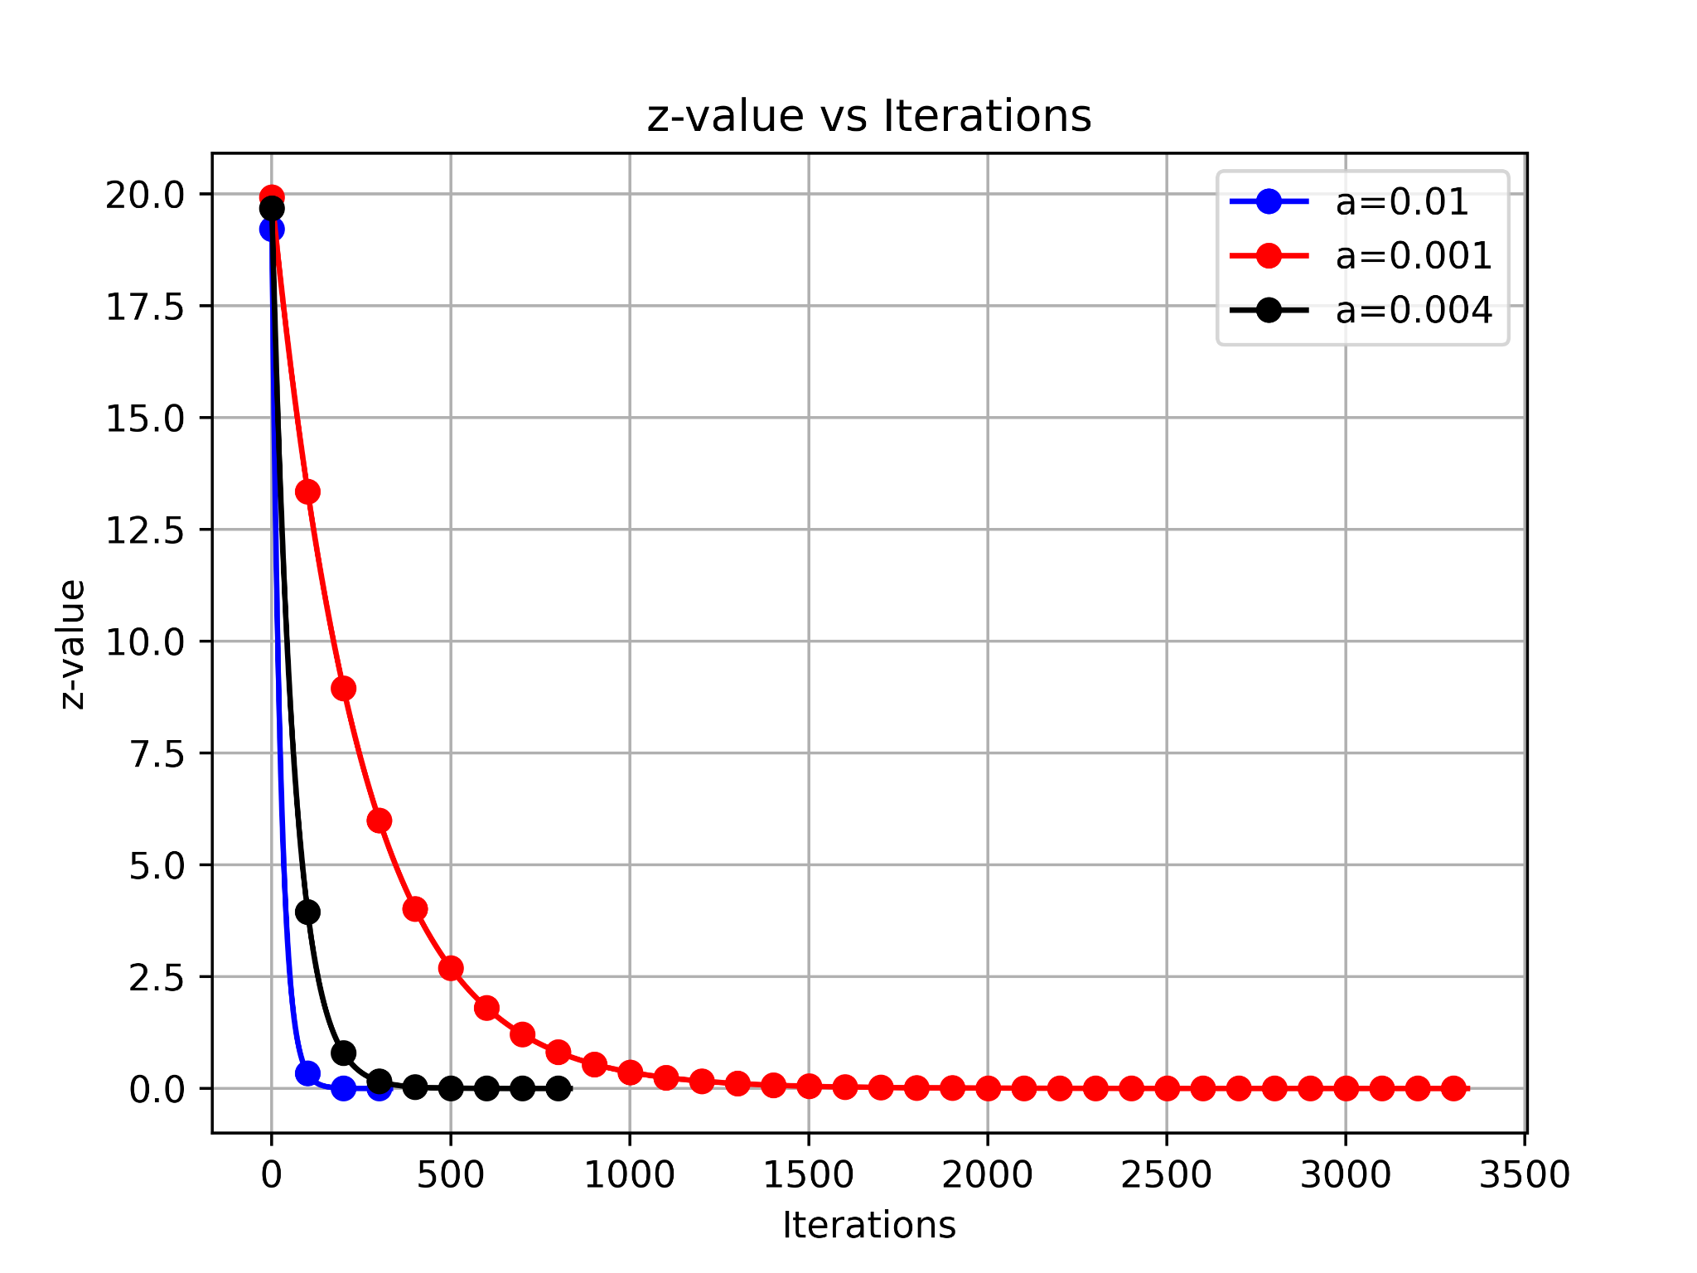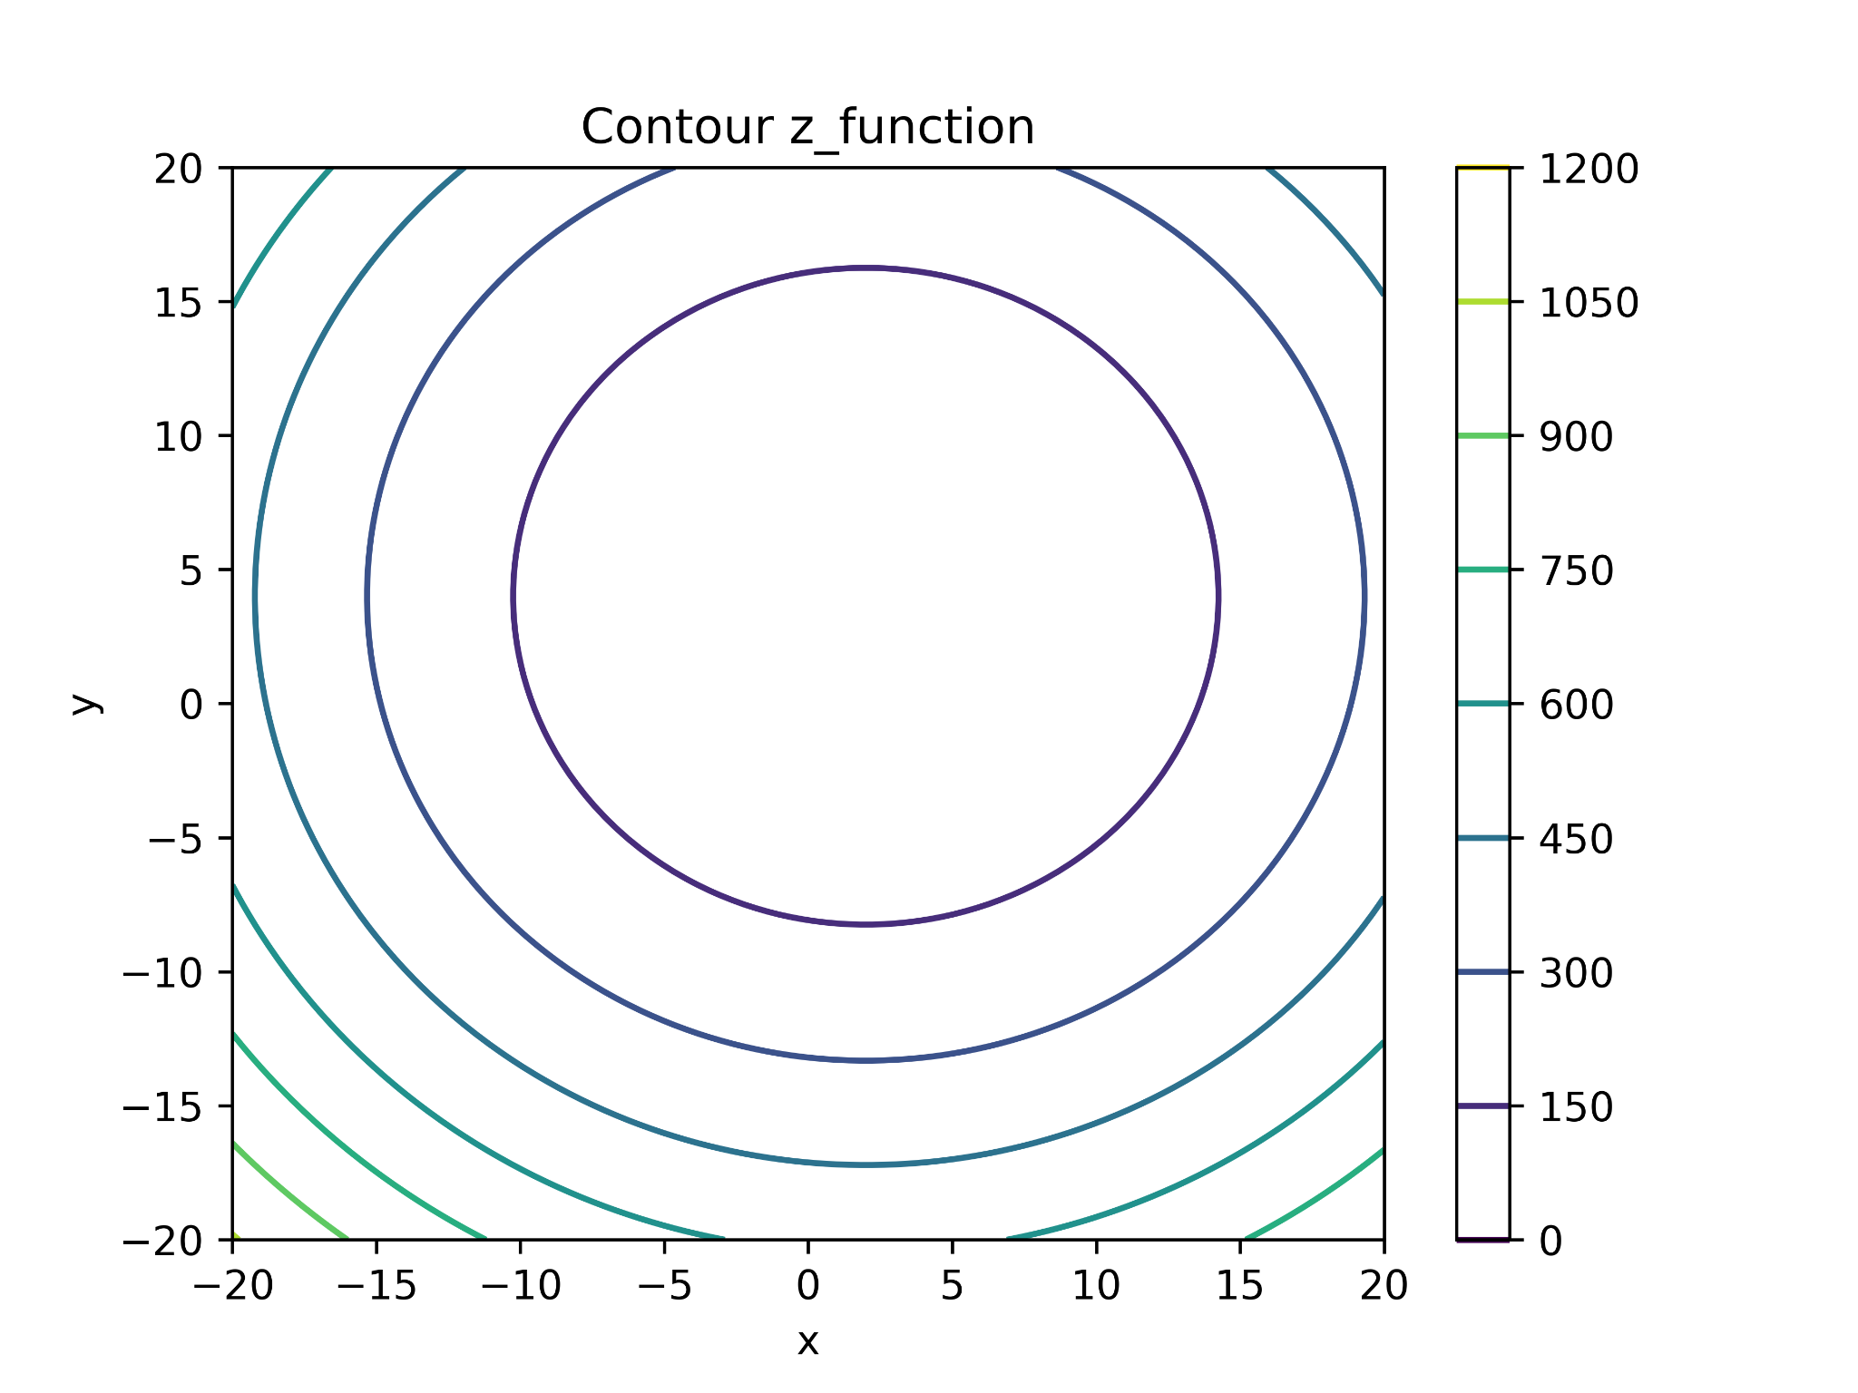
- Input parameters-
Tolerance value of gradient = 1e-2
Initial (x,y) value = (0,0)
Learning rates- 0.01, 0.001 and 0.004

- Output parameters-
Final solution is (1.9975560792116491, 3.9951121584232983) for learning rate=0.01 at 332 iterations
Final solution is (1.9975051875912724, 3.9950103751825448) for learning rate=0.001 at 3340 iterations
Final solution is (1.9975352971217475, 3.995070594243495) for learning rate=0.004 at 834 iterations

- Observation-
- For all learning rates (a=0.01, 0.004, 0.001), the z-value decreases monotonically as the number of iterations increases.
- For a=0.01, converges very fast, reaching near zero at 332 iterations.
- For a=0.004, slower convergence at 834 iterations.
- For a=0.001, slowest convergence at 3340 iterations.
- The contours are concentric circles, indicating a convex and smooth optimization surface.
- No divergence, indicating that learning rates taken are optimal.

- Discussion-
- A higher learning rate (a=0.01) allows for much faster convergence, as seen in the blue curve. However, in more complex functions, such a high rate might risk divergence.
- A very small learning rate (a=0.001) ensures stability but at the cost of slow convergence, requiring thousands of iterations.
- An intermediate learning rate (a=0.004) balances speed and stability better, though still slower than a=0.01.

- For $g(x, y) = 5x^{2}−30x+y^{2}−8y+4xy+34$
Output-
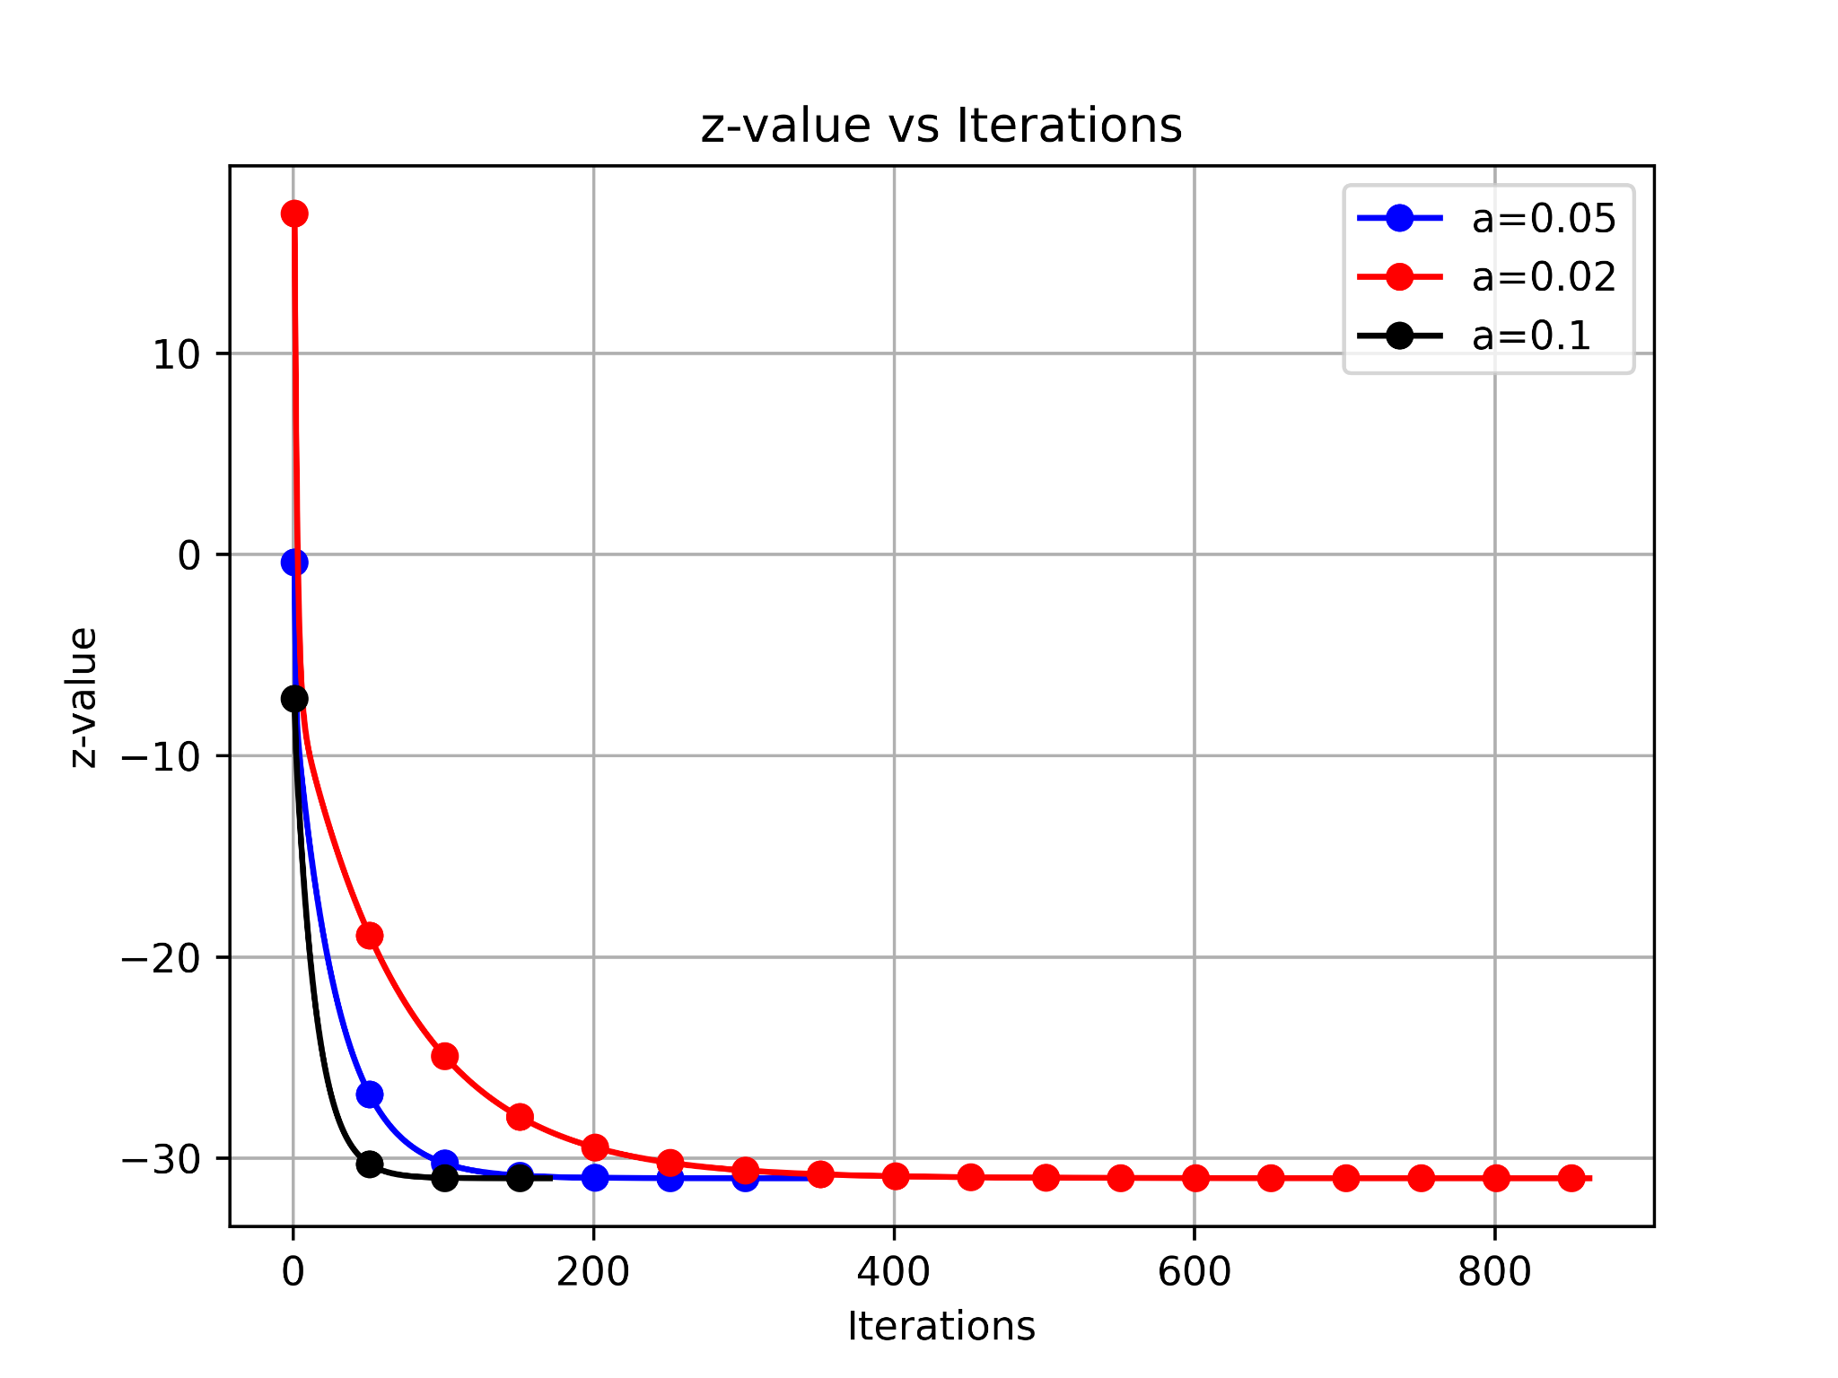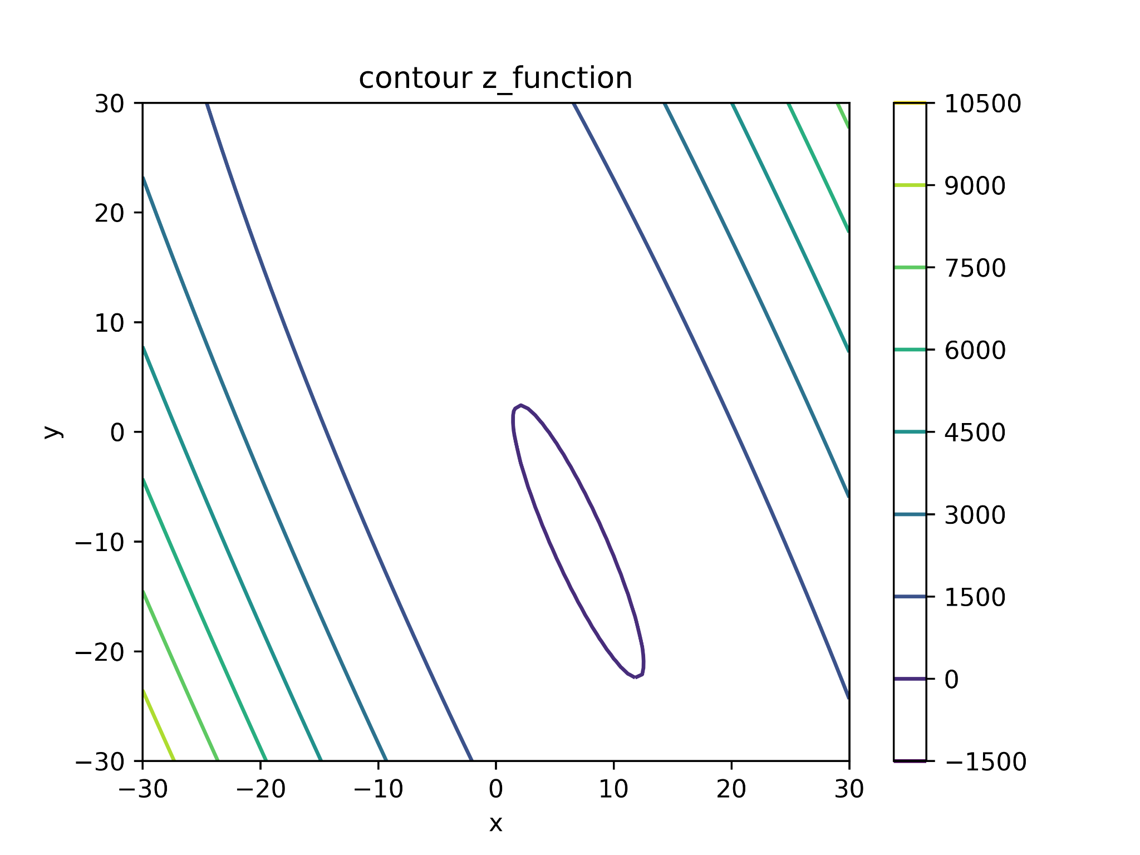

- Input parameters-
Tolerance value of gradient = 1e-2
Initial (x,y) value = (0,0)
Learning rates- 0.05, 0.02 and 0.1

- Output parameters-
Final solution is (6.988155104802789, -9.971403893370004) for learning rate=0.05 at 344 iterations
Final solution is (6.988033512105501, -9.971110342631128) for learning rate=0.02 at 863 iterations
Final solution is (6.988360658175658, -9.971900143110576) for learning rate=0.1 at 171 iterations

- Observation-
- For all learning rates (a=0.05, 0.02, 0.1), the z-value decreases monotonically as the number of iterations increases.
- At a=0.1, the convergence is the fastest reaching zero at 171 iterations.
- At a=0.05, the convergence is slower reaching zero at 344 iterations.
- At a=0.02, the convergence is the slowest reaching zero at 863 iterations.
- The contours are concentric elliptical.
- No divergence, indicating that learning rates taken are optimal.

- Discussion-
- A higher learning rate (a=0.1) allows for much faster convergence, as seen in the blue curve. However, in more complex functions, such a high rate might risk divergence.
- A very small learning rate (a=0.05) ensures stability but at the cost of slow convergence, requiring thousands of iterations.
- An intermediate learning rate (a=0.02) balances speed and stability better, though still slower than a=0.05.

Q2.
Use the above developed program to understand the gradient descent method better. In order to do so, consider a function, f(x, y) with the value of the “a” changing from one to 1000 . Play with the learning rate and value of the a to observe the effect of these on the convergence on the optimization iterations.

Solution-
- Input parameters-
f(x,y) = $(x^{2}+ay^{2})$ for a=10, 50, 200
Learning rates l= 0.0001, 0.0005, 0.0007
Initial (x,y) value= (1,1)

- Output parameters-
Convergence rates

- Observation and discussion-
- Case a=10-
All three learning rates produce monotonic decrease of f(x,y) (no divergence). Larger learning rate (l=0.0007) converges faster than 0.0005, which is faster than 0.0001.
Faster convergence due to small “a”

- Case a=50-
The three rates show the same result with l= 0.0007 being fastest, l=0.0005 being slower and l=0.0001 being slowest. However, due to the larger value of “a”, the convergence is slower in all cases.
The number of iterations have decreased noticeably due to the “steeper” value of “a” along the y-axis which also results in “steeper” convergence due to faster drop.

- Case a=200-
Again, the three rates show proper convergence but the iterations required have further decreased due to larger values of “a”. As such, instability can be introduced (such as the “zig-zagging” path followed along the function, where the gradient descent is faster at steep points and slower at flatter surfaces.)
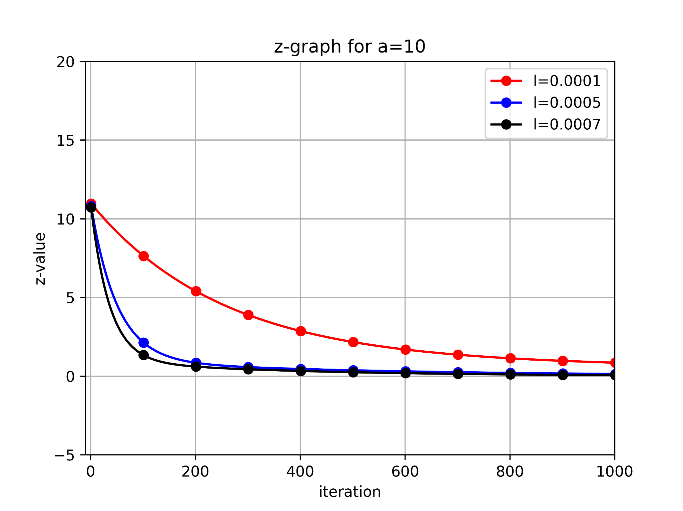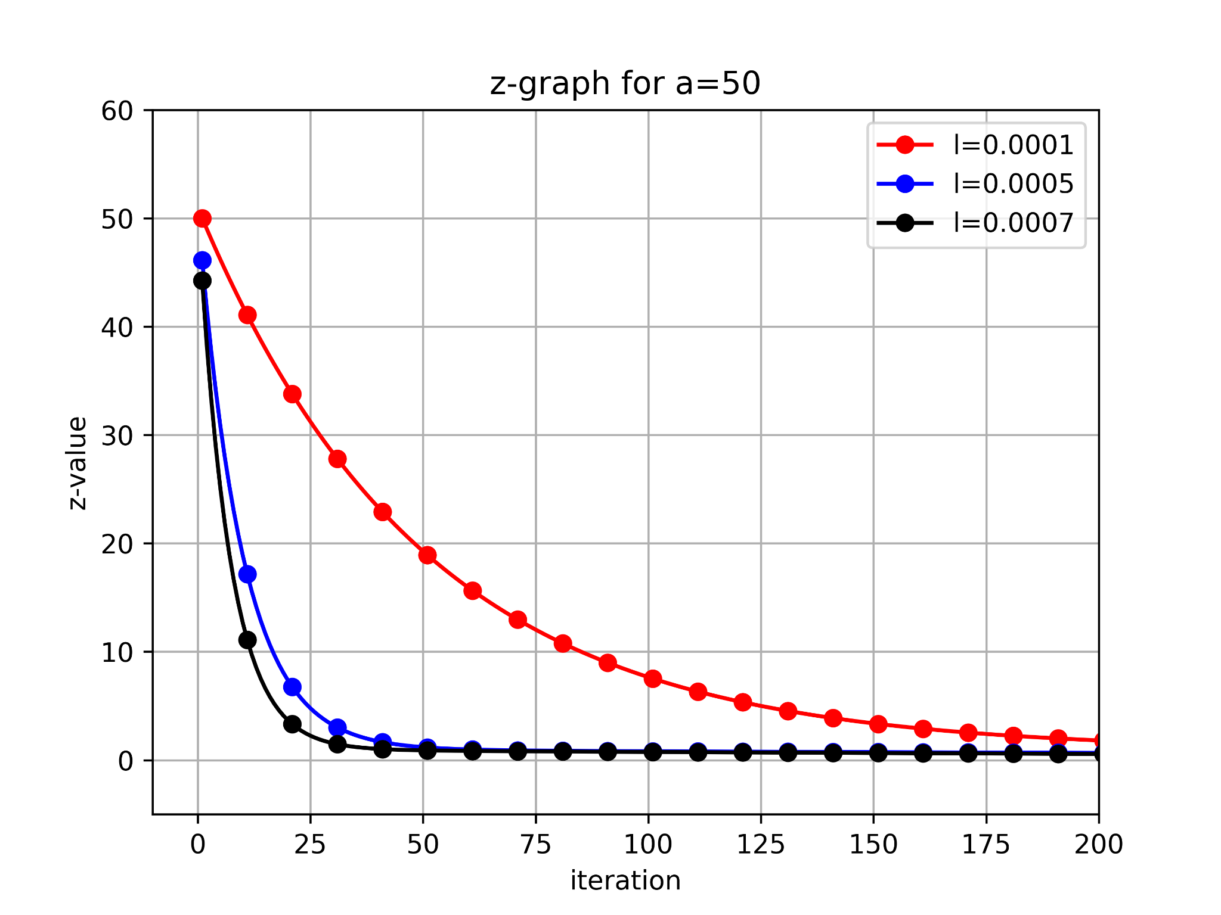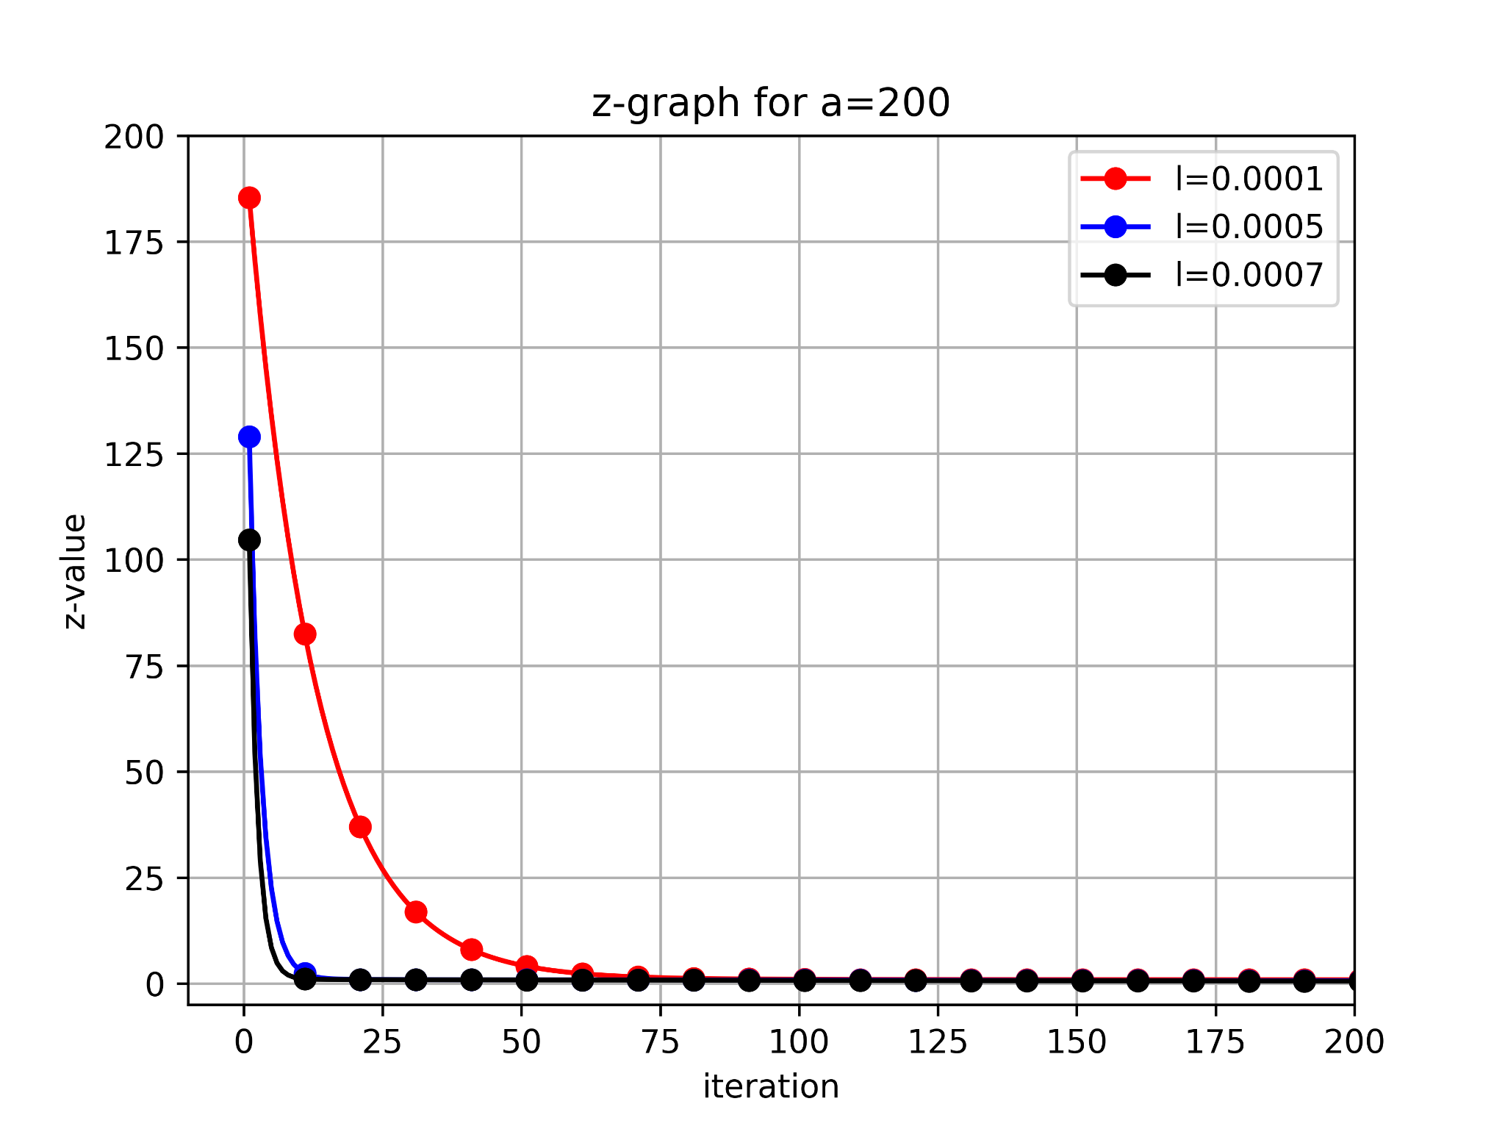
The gradient descent function can be observed in action here, notice the convergence slowing at flatter sections while large steps taken as steeper sections


Q3.
Now we are going one step further and try to solve a constrained optimization problem for two variables.

f(x, y)= min $(y^{3})$
s. t. $x^{2}+4y^{2}≤24$
x+y ≤ 0

Solution-
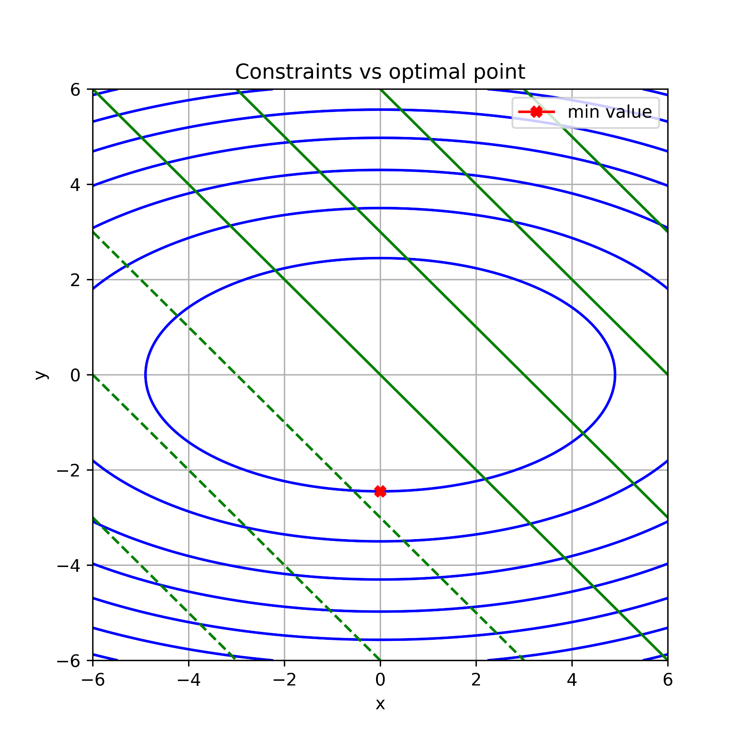

For a=1
- Input parameters-
f(x, y)= min $(y^{3})$
s. t. $x^{2}+4y^{2}≤24$
x+y ≤ 0
Case 1: Both constraints inactive ($λ_{1}$=$λ_{2}$=0)
Optimum point: (x,y)=($-\sqrt{24},0$)
Both constraints $g_{1}$(x,y)≤0 and $g_{2}$(x,y)≤0 must be satisfied.
Case 2: One constraint active ($λ_{1}$>0 and $λ_{2}$=0)
Optimum point: (x,y)=($0,-\sqrt{6}$)
Both constraints $g_{1}$(x,y)≤0 and $g_{2}$(x,y)≤0 and $λ_{1}$>0 must be satisfied.
Case 3: Other constraint active ($λ_{1}$=0 and $λ_{2}$>0)
Optimum point: (x,y)=($2,-2$)
Both constraints $g_{1}$(x,y)≤0 and $g_{2}$(x,y)≤0 and $λ_{2}$>0 must be satisfied.
Case 4: Both constraint active ($λ_{1}$>0 and $λ_{2}$>0)
Optimum point: (x,y)=($\sqrt{24/5},-\sqrt{24/5}$)
Both constraints $g_{1}$(x,y)≤0 and $g_{2}$(x,y)≤0 and $λ_{1}$>0 and $λ_{2}$>0 must be satisfied.
- Output parameters-
the value of (x,y)= 0 and -2.449489742783178
value of langrange1 and langrange2= 5.51135192126215 and 0
minimized value = -14.696938456699066

- Observation-
- The KKT conditions were applied manually in code. Several candidate points were checked:
- Case where both constraints are inactive.
- Case where only the ellipse is active.
- Case where only one line is active.
- Case where both are active.
2. From the KKT multipliers (lambda 1 and lambda 2), the program automatically filtered out infeasible or inactive cases and chose the feasible point with the lowest objective value.
- Discussion-
- The optimal solution lies close to the intersection of the ellipse boundary and the line constraint. The line constraint cuts the ellipse diagonally. The optimal point occurs near this line.
For a= -1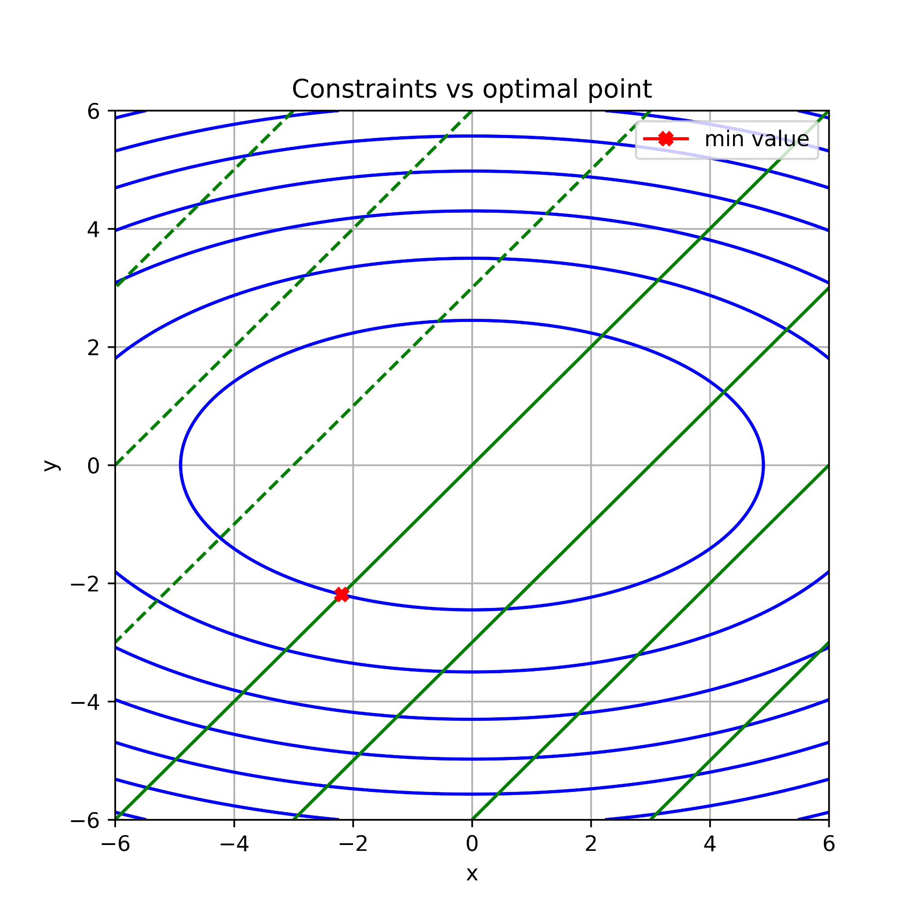
- Output parameters-
the value of (x,y)= -2.1908902300206643 and -2.1908902300206643
value of langrange1 and langrange2= 0.821583836257749 and 0
minimized value=-10.516273104099188

